Project Charter-Project 1
The Scope of Work of project 1 is to design and erect a plant producing internal components of an automotive combustion engine. The building will be constructed in Gora Padao Haldwani, India, and the project partner, Global Prime Cars, has already acquired the land indicated.
The first phase of the project is the Engineering Phase and involves the definition of the production process and its layout. Using concurrent engineering, we have assumed that both tasks can be performed simultaneously, but to do this, we must establish strong communication between the Italian and Indian engineering teams.
To perform the crash of project 1 we selected those tasks which were crashable, namely those along the critical path where we were able to add additional resources.
Then, we calculated the new durations once we knew the new amount of resources allocated to each task. For some tasks, we computed several options since more than one resource was available for such task.
For the task “Detailed Engineering process” we had 3 options:
- Add 1 Italian Specialized Engineer;
- Add 1 Italian Project Engineer;
- Add 1 Italian Specialized Engineer and 1 Italian Project Engineer;

For each of these options we calculated the duration once the task was crashed, the new cost considering that each crashing unit earn double of the rate of a normal employee and the overhead costs, computed as the overhead rate multiplied by the days of reduction.
The total cost of the crashing operation is given by the sum of these two costs.
We performed the same reasoning for the “Detailed engineering layout”.
The second phase is that of the Civil Works Refurbishment Erection Phase, which is entirely allocated to the owner of the plant, namely Global Prime Cars. We have assumed that the tasks can overlap by a time frame ranging from 10 to 25 days, so as to significantly reduce the time taken by the entire phase. The most important task is that of Flooring, since only once the latter is completed at least 50%, the machines can arrive at the site and can therefore be installed.
In order to ensure proper coordination between the two companies, a meeting was agreed between the parties at the end of the phase.
At the same time as the previous phase, the Purchasing Process takes place, linked to the purchase of all the machinery necessary for production. Regardless of the manufacturer chosen to purchase the machinery, orders are divided according to the type of machine in question. All orders are placed by a Purchasing Agent.
In the following table (Table 1) are shown the machineries with the relative suppliers
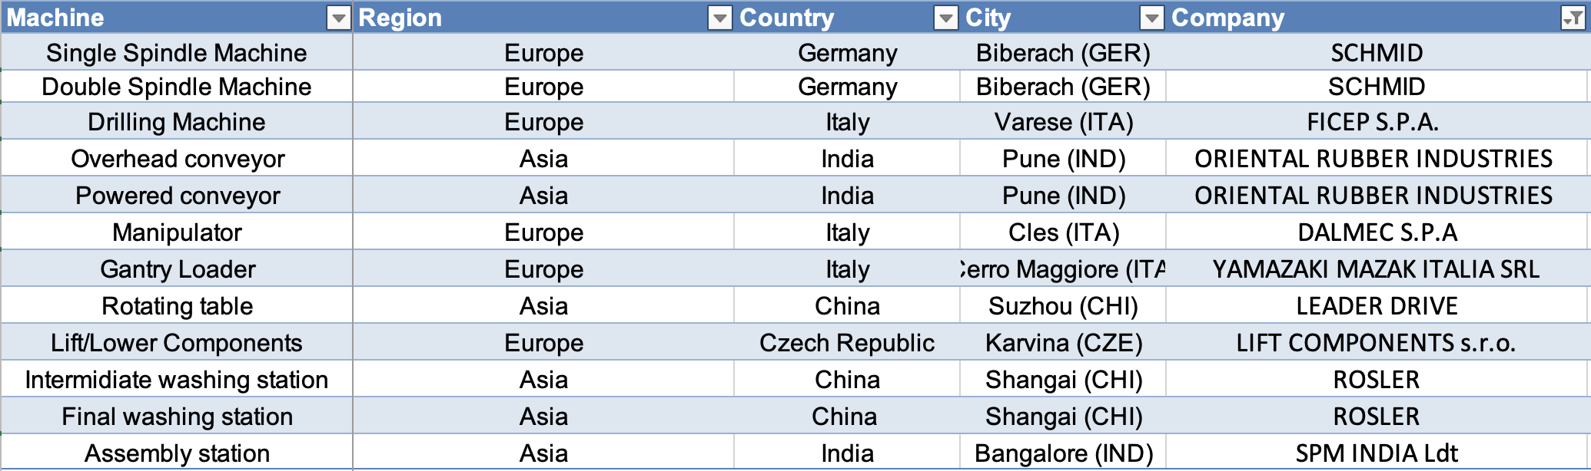
Table 1: Ordered machinery and relative suppliers
The next phase is the Equipment Manufacturing Phase and involves the manufacture by suppliers of the machines chosen in the previous phase. In this phase it happens also the payment of all the machinery, made by the purchasing agent: this task acquires relative importance as it represents a temporal constraint to the start of the project 2 and the project 3.
Once the machine construction tasks are completed, the Trasportation Phase takes place, in which the various suppliers send their products to our Indian plant.
Three modes of transport linked to the location of the supplier have been identified: these modes are listed in the Table 2. In Table 3 we have calculated the total cost for the transport of the machinery: in order to arrive to such figure we have calculated how many TEU are moved for every machinery (this figure is rounded up because the containers used for transport can only be rented in full) and we have multiplied them by the cost of that route by TEU.
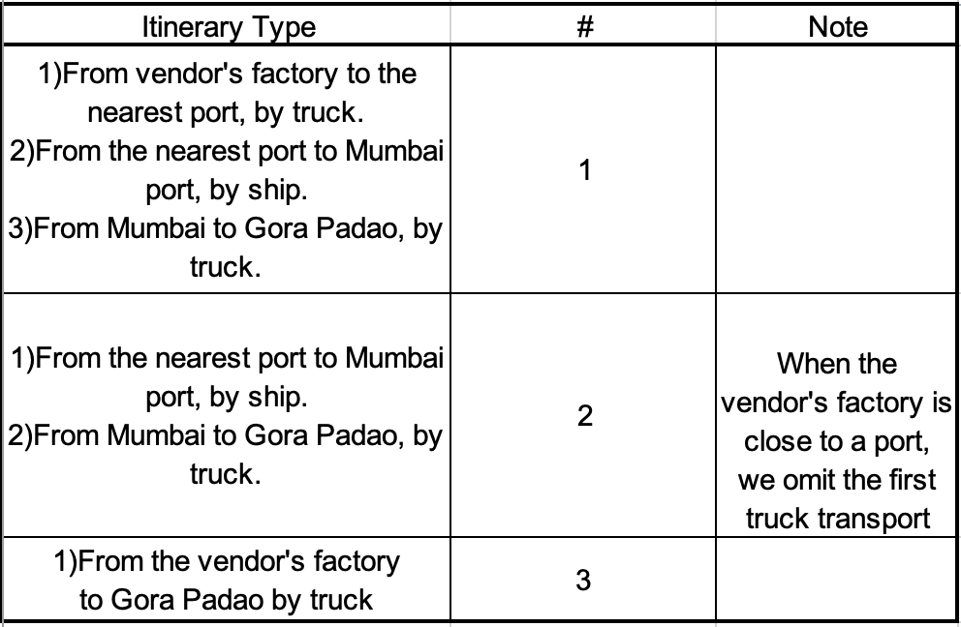
Table 2: types of routes identified
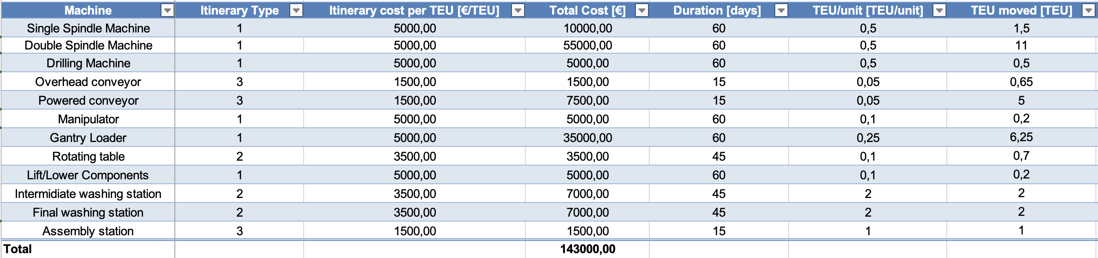
Table 3: machinery and respective itinerary type and cost
The TEU moved has been calculated by multiplying the TEU/unit by the number of machineries required for our plant.
$$TEU moved=TEU/unit⋅number of machinery required$$
Then, we calculated the total cost by multiplying the TEU moved (rounded up to the first integer number, as we cannot rent only a part of the TEU) by the itinerary cost per TEU
$$Total Cost=\left\lceil TEU/unit\right\rceil ⋅Itinerary cost per TEU$$
At this stage, finish to finish relationships have been used compared to the flooring task, as to get the machines to their destination it is necessary that at least 50% of the flooring is completed.
The rate of completion of the flooring for the arrival of the products varies from machinery to machinery, as we have assumed that the staggered arrival of the machinery involves a lower risk of accidents, caused by the excessive stock of machinery on the unfinished pavement.
The next step is the On Site Erection Phase. The order of operations was decided on the basis of the arrival of the machinery, taking into account that up to 3 operations can be carried out in parallel.
Hence, we come out with the following orders of operations:
- OP. 20$→$OP.30$→$OP.50$→$OP.100
- OP. 60$→$OP.40$→$OP.90
- OP. 70$→$OP.10$→$OP.80$→$OP.110

The last identified phase is Final Testing. This phase is important because, following its completion, it will also be possible to complete the test phases of project 2 and project 3.
Crashing
To perform the crash of project 1 we selected those tasks which were crashable, namely those along the critical path where we were able to add additional resources.
Then, we calculated the new durations once we knew the new amount of resources allocated to each task. For some tasks, we computed several options since more than one resource was available for such task.
For the task “Detailed Engineering process” we had 3 options:
- Add 1 Italian Specialized Engineer;
- Add 1 Italian Project Engineer;
- Add 1 Italian Specialized Engineer and 1 Italian Project Engineer;

For each of these options we calculated the duration once the task was crashed, the new cost considering that each crashing unit earns double of the rate of a normal resource and the overhead costs, computed as the overhead rate multiplied by the days of reduction.
$$Costs=2⋅wage rate ⋅days of work$$
$$Overheads=1000 ⋅ days of reduction$$
The total cost of the crashing operation is given by the sum of these two costs.
$$Total costs=costs+overheads$$
We performed the same reasoning for the “Detailed engineering layout”.
We also decided to do a crashing activity on the Erection phase, adding 3 teams of indian workers to those already present: this allows us to halve the duration of the tasks that were on the critical path. We didn’t add the Italian workers teams because they don’t participate in tasks that are on the critical path. In addition, we preferred to halve the durations of some tasks rather than have the crashing team perform tasks in parallel (thus having 4 paths in parallel in total) because this allows us to have a smoother allocation of resources. This reasoning is highlighted by the following images:

Figure 1: tasks duration when the crashing team is used to shorten the duration of some activities

Figure 2: tasks duration when the crashing team is used to perform 4 tasks in parallel
Concerning the last phase, Final testing, we evaluated if it was worth to perform the crash. We have identified 6 possible options, namely:
- Add 1 specialized engineer;
- Add 2 specialized engineers;
- Add 3 specialized engineers;
- Add 1 team of workers;
- Add 2 team of workers;
- Add 3 team of workers;

We performed the same reasonings as before, but in this case the costs were too high if compared with the reduction in the overall duration. Hence, we decided to not perform any crash on this task.
All the costs are shown in the Table 3. In the computation of the final total costs, we considered only those highlighted in bold, as that were the actual crashing we decided to perform. The total cost given by these operations is equal to €513 160, with a total reduction of 340 days.
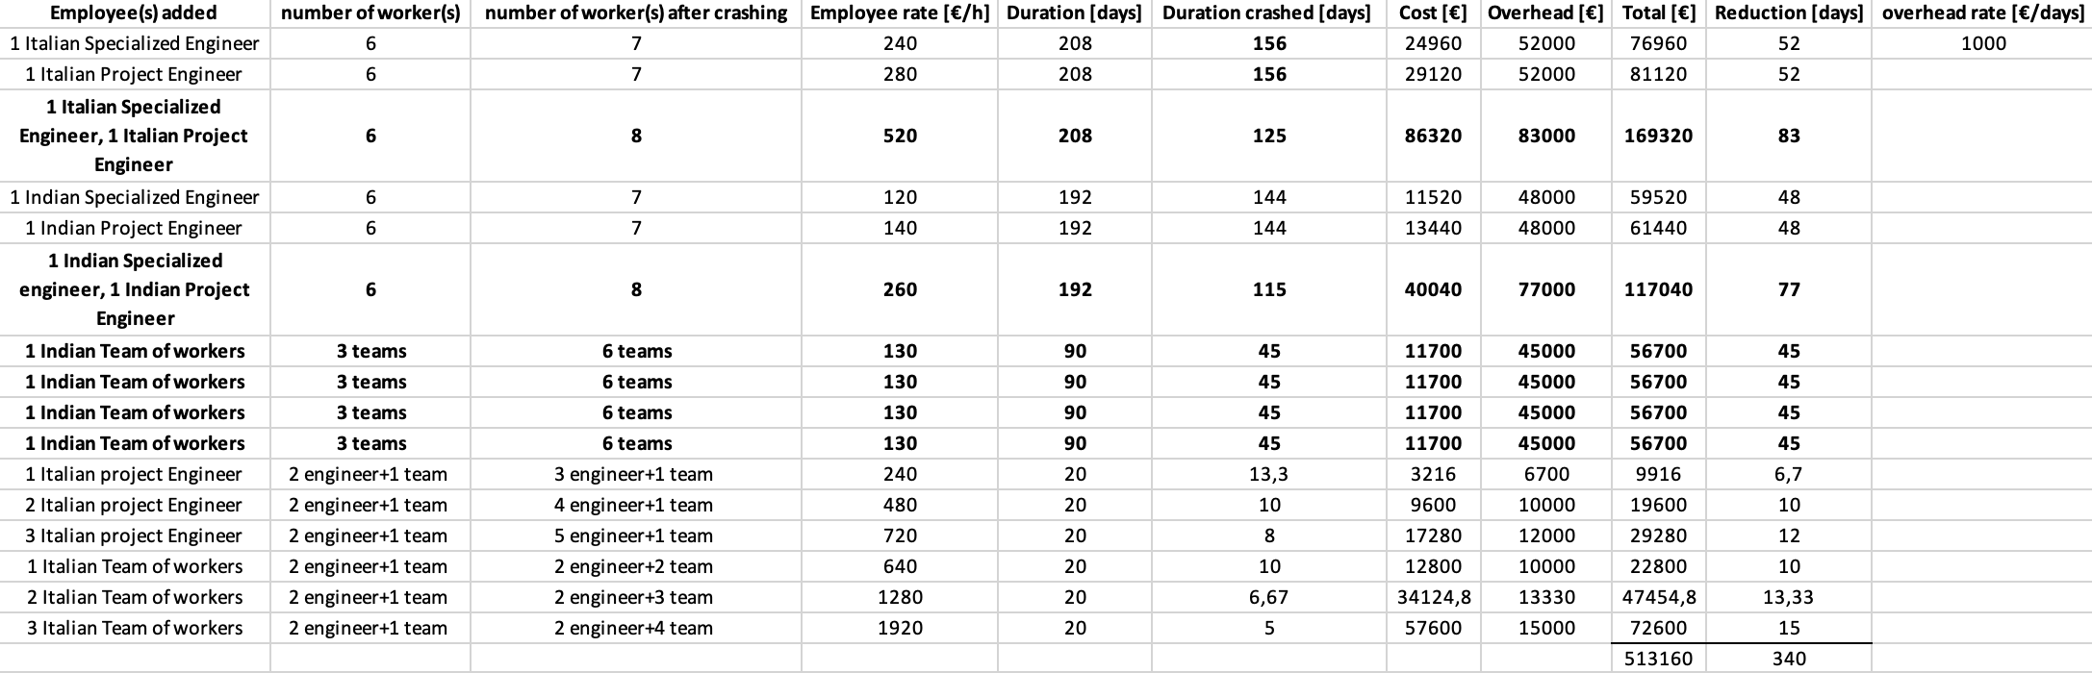
Table 4: crashing options. Only the bald operations have been actually implemented.

Attachment
Summary project charter
Project name | Project 1
Stakeholders | Global prime cars, Italian partner
Objectives and Potential Constraints | The main objective of this project is to design and build a facility situated in Gora Padao Haldwani, India. It must be complete in all its parts, including the design of the process layout and the erection of the machineries needed. The plant has to produce internal components of an automotive combustion engine and is the result of a partnership between our Italian firm and Global Prime Cars.
Relationships with other Initiaitives | The project starts on 15/01/2024. The main phases are: Engineering Phase, Civil Works Refurbishment Erection Phase, Purchasing Process, Equipment Manufacturing Phase, Transportation Phase, On Site Erection Phase and Final Testing.
Entities and Resources Involved | There are several entities involved. The Owner is the one responsible for the construction of the building. The supplier is responsible for the manufacturing of the equipment and the logistic service provider for the transportation.  All the other tasks are performed by the Italian and Indian Specialized Engineer, the Italian and Indian Project Engineer, the Purchasing Agent and the Italian and Indian team of workers
Expected Outcomes and Scheduled Dates | The expected outcome of the project is the realization of a fully working establishment, complying with the resources and time constraints. The project is expected to start the 15/01/2024 and completed within 547 days, on the 17/02/2026
Cost Estimate | The overall cost is equal to 24 600 000€

